**ENEL 453 Lab 3 Report**

Aidan Johnson

Luke Garland

**Timing Report:**

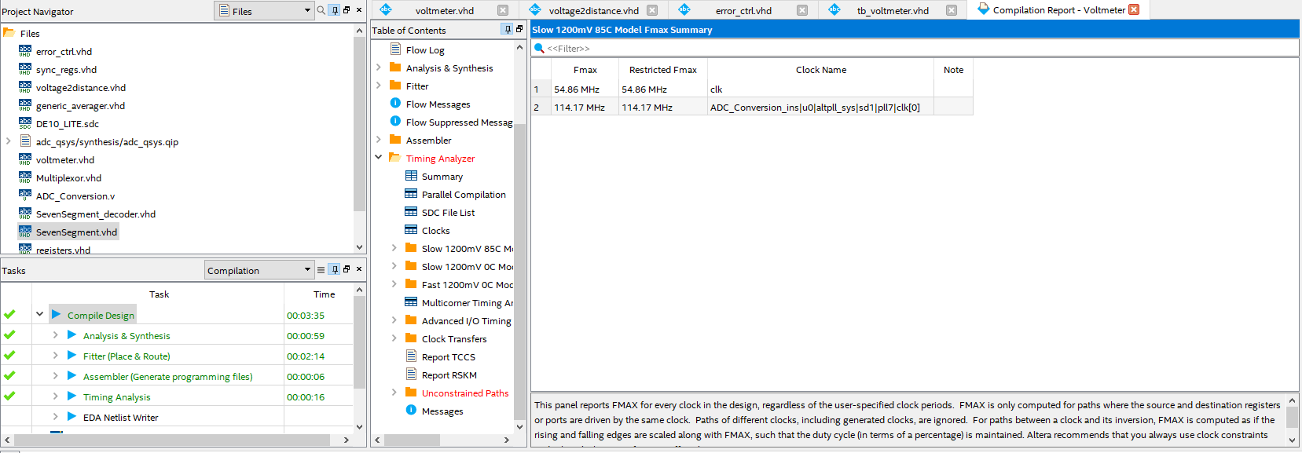

**Top Level RTL Schematic:**

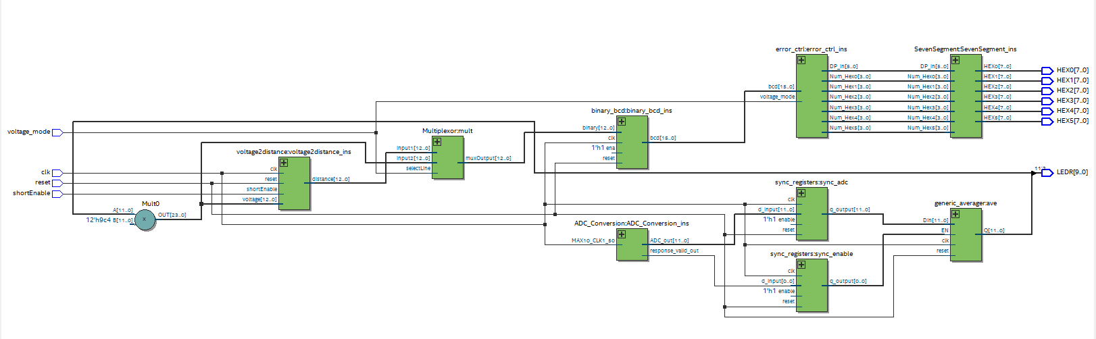

**Top Level Simulation:**

